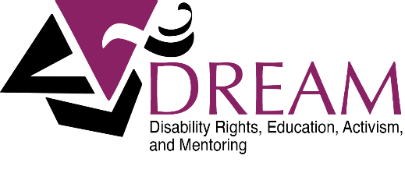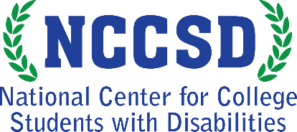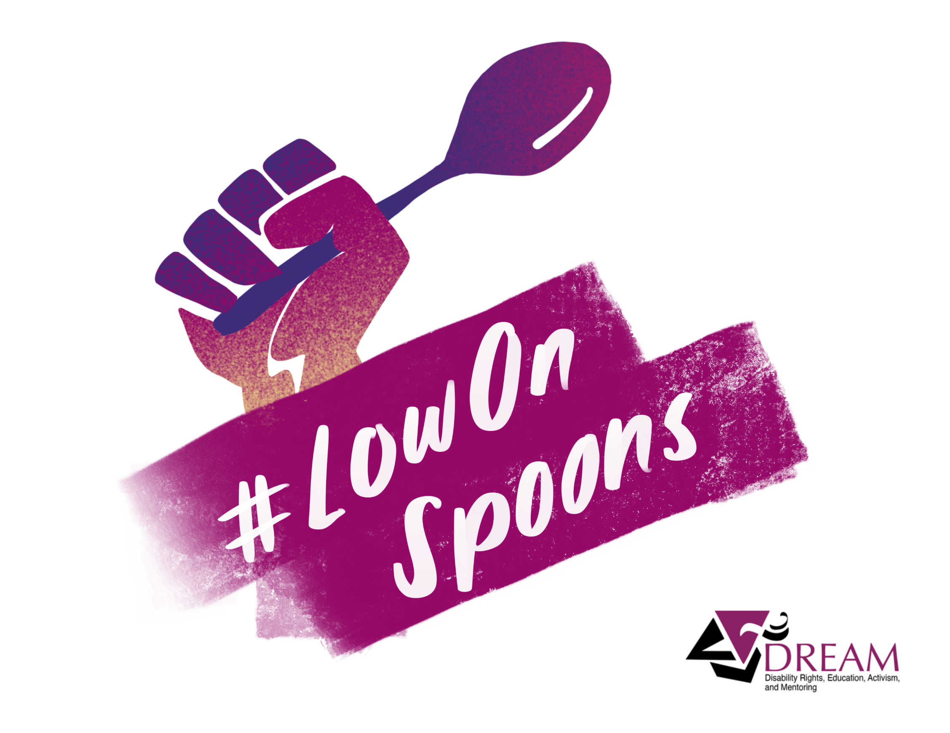

DREAM at the NCCSD is funded by a grant to the Association on Higher Education And Disability (AHEAD) from the U.S. Department of Education (P116D150005).

Alternate formats of this handout are available upon request by contacting DREAM@ahead.org

#LowOnSpoons Week

April 27-May 1, 2020

www.DREAMCollegeDisability.org